Digitalteknik labb 1
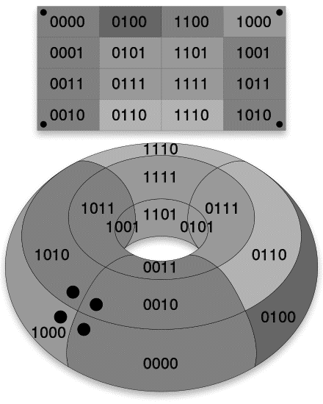

Emil Jons, ET061G, Lab 1 TTL Circuits

Purpose
The purpose of this laboratory is to introduce logic circuits and how they work. Using TTL circuits, or Transistor Transistor Logic, the optimal function is built.

Results
Below all the tasks are shown, with a short description of what was done in the given task.
Task 1:
These drawings represent how a 74HC00 IC works. It consists of 14 pins, where pin 14 is for voltage source and 7 is for ground. The remaining 12 pins consists of 8 inputs and 4 outputs where each set of inputs and outputs do the same thing. They perform the NAND logic operation on the signal and outputs the result. For instance, if you want to perform the, NAND, operation on two signals, you’d want to connect the first signal to pin 1 and the second to pin 2. This will give you the output on pin 3.

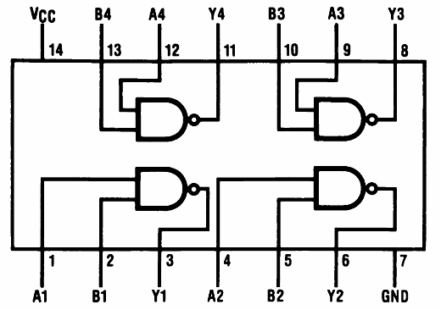
Figure 1: Connection diagram of 74HC00

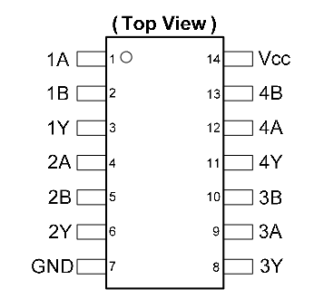
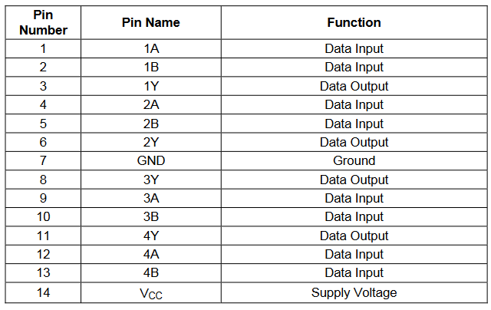
Figure 3: Component overview with labeled pins
Figure 2: Pin description of 74HC00

Task 2:
The drawing below shows the Karnaugh map of the function with the groups that was used for the simplification of the function. It also shows the truth table and the function, equation (1), that was used for the simplification.

Figure 4: Truth table and Karnaugh map with groups
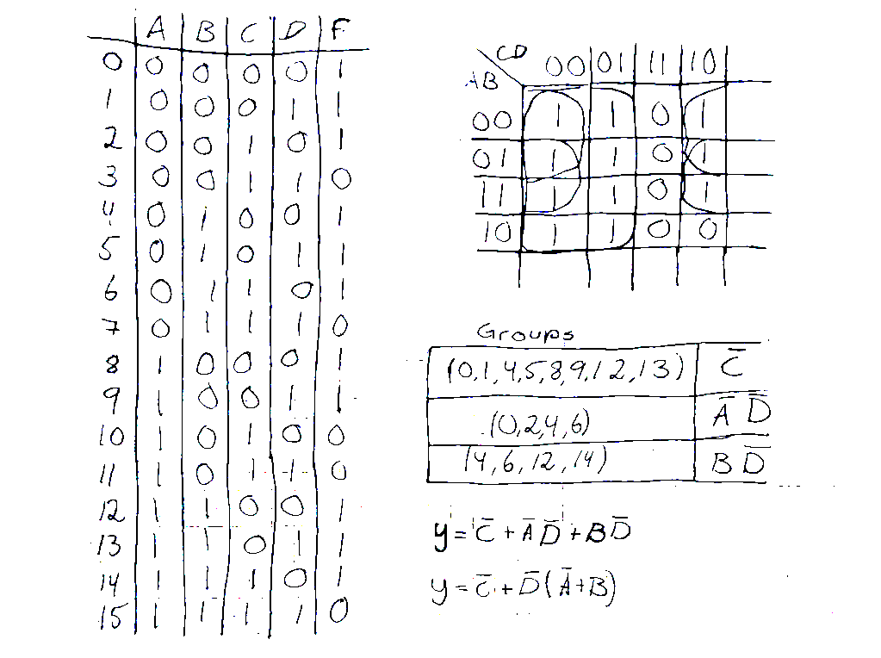

(2)

First the truth table was put up by looking at the function, where the function returned a 1 when a specific number was put in. With the truth table put up, a K-map could be drawn, and groupings can be made. Using the new groupings, the optimal function, equation (2) could be made.

Task 3:
This is the gate network for the simplified function, where the switches represent the bits being either on or off.
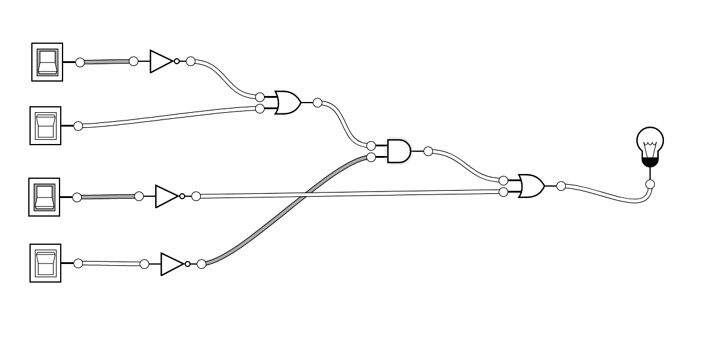
A
B
C
D
Figure 5: Gate network of the function
Because we have four bits, we also use four switches where A is the MSB and D is the LSB. Depending on what switches are switched on, the light will light up according to the function. If for instance all the switches are turned off, the light should light up when looking at the truth table.

Task 4:
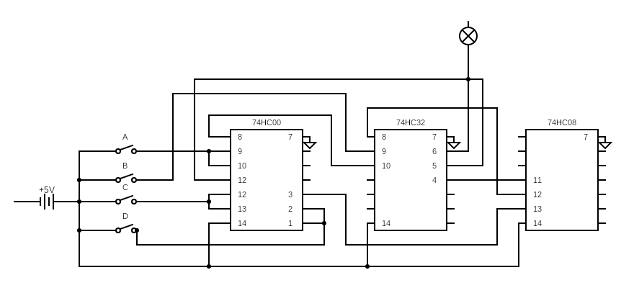
Below is the circuit diagram of the simplified function implemented with TTL IC’s. The different IC’s used was 74HC00, 74HC32, 74HC08 which respectively contain NAND, OR, AND gates. By looking at the datasheet of the components used, the IC’s could be connected according to the gate network. Additionally, a voltage source of 5v was connected to pin 14 and ground was connected to pin 7 with all the components.

Figure 6: Circuit diagram of the function using IC's

